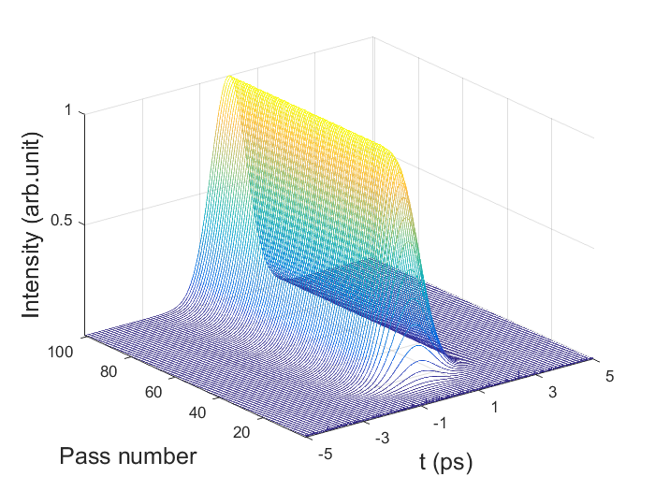

Fig 1. Pulse evolution in the cavity

The model of the self-started Kerr-lens mode-locking procedure consists of a laser gain media and an intensity modulator. The laser gain media can be thought of as an amplifier that has a gain line shape, which can be modeled by a frequency filter. As for the amplifier, the saturation effect should also be taken into account and its effect on the gain factor G is given as

,(1)

Where *g*ss is the small-signal gain factor, *P* is the signal power, *P*sat is the saturation power. With regard to the gain line shape, Pr3+:YLF laser is solid-state laser with a gain-line shape corresponds to Lorentzian profile which belongs to homogeneous broadening [2016, Li Qing-Song]. The gain coefficient can be expressed as

 (1)

where  is the central frequency and  is full width at half-maximum of the laser gain-line shape.

The signal is then passed through a bandpass filter. The filter is modeled as

a first-order transmission transfer function with a Gaussian profile

[2016, Li Qing-Song]. “The effect of the depth of single longitudinal mode modulation in Q-switching pre-Pr3+:YLF laser”